Institute of Minecraft Studies Journal

First Edition
Published 03/05/2026

Edited by: ghastlygrenadine, koviubi, MrMillerPink, retrooper, Rev
Editor-in-chief: matcha_tea

Originally published on the Institute of Minecraft Studies Discord server
Contents
Foreword 3
Fun, wins, and losses 4
Fun in multiplayer environments 10
Raid Farms: A symbol of resistance 15
The Five Motivations 22
Social Priming and Server Well-Being 24
Afterword 30

Access the IMS database for the first edition here:
https://github.com/imsresearch/IMS-database/tree/main/journal/first-edition

Every effort has been made to ensure that factual accuracy, clarity, spelling, and grammar are correct. Information has been independently researched by respective authors. The journal and its editorial board can only produce what authors have provided and are accepted to be correct in good faith. Readers are encouraged to report any inaccuracies, grammatical errors, or any other errors to the board via Discord direct message to matcha_tea.
Feedback is also welcomed by the board and can also be given via the same method above.

Foreword
By: First Edition editorial team
It is with great pleasure that we welcome readers to the first collection of pieces for the Institute of Minecraft Studies. The Institute of Minecraft Studies is where innovative ideas are developed, challenged, and tested. The pieces we present to you in this collection are based on the critical thinking of various writers in our community.
This issue contains two theories and three essays that we consider essential for an introduction to the work of the Institute of Minecraft Studies.
First, MrMillerPink shares useful strategies that can be applied to the design of a Minecraft server to promote community building.
In the following article, Rev critically responds to the previous piece, suggesting that there exists important aspects that Minecraft players value aside from the design of the server, and thus, the author suggests that the Minecraft multiplayer experience is different from the experience on other video games.
Next, matcha_tea shares her experience on Raid Farms, what used to be a popular Minecraft server. She develops a hypothesis of what led to its decline in popularity.
Snorka writes the first Minecraft Theory which addresses the why players have fun on servers.
The second theory, developed by Moldypizzar0ll, provides an analytic philosophical argument for the decline in Minecraft server social life, where groups of players isolate themselves from everyone else on the server. He concludes with viable solutions for amending these issues.
The pieces mentioned here serve as examples for anyone interested in contributing to the debates featured by the Institute of Minecraft Studies. We believe that the theories and articles presented are timely. We also view the pieces as useful prompts for anyone interested in designing a Minecraft server. Please note that the opinions conveyed in the theories and articles do not necessarily represent the position of the Institute of Minecraft Studies. The institute serves to promote well-reasoned debate and the dissemination of Minecraft theories.
Finally, we extend our gratitude to the contributing authors for working with us in editing and refining their manuscripts. They have helped us bring forward their theses in the most concise and articulate way possible. The team also thank the help of Turtle for his continued and invaluable work in organisation within the Institute of Minecraft Studies.

NB: Each journal will have an IMSC after its title. This is its Institute of Minecraft Studies Code, which you may use to find the resources (media, graphs, etc.) attached in the article. You may also find the standalone document using this code. Go to the IMS database and look for the article code.

Fun, wins, and losses
IMSC: 1MK1
By: MrMillerPink, edited by: koviubi
Introduction
In activities of any kind, a type of win and loss will be present. Whether it is finishing your build in a building game, having it be destroyed, or finding loot in adventures. However, you may not recognize that winning can be a broad term applicable in many contexts, and the same can be said for losses. Both have their own consequences towards players. Thus, when designing Minecraft servers, one must be especially familiar with the topic so crucial to fun.
This article provides more clarification on fun, winning, and losing in videogames, highlighting key information I’ve learned throughout studying game design.


I. What is fun?
What I’ve noticed during my time in the Institute of Minecraft Studies (IMS) Discord server, is the rather arbitrary understanding most people have of fun. Fun is not exclusive to a specific activity like socialization, player interaction, rivalry, or teamwork! There are many ways to have fun and players prefer different activities. Therefore, excluding other activities by entirely dedicating our research to a few would be delinquent.
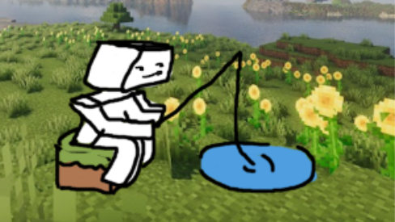
We need a definition of fun for this article to even exist. I’ll be using Gabe Newell’s “ad hoc definition” of fun which he stated in an interview.[1] Gabe Newell is the CEO of Valve, an American video game developer, publisher, hardware, and digital distribution company. He is a competent game designer and was involved in the making of the corporation’s earliest games. He and his team defined fun as “the degrees to which the game recognizes and responds to the players’ choices and actions”.

This definition is the best one I know. Some degree of time and effort is put into every choice the player makes: be it walking, breaking blocks, fighting monsters, etc. It’s really important for game designers to reward players for their efforts, as it’s the basis for fun to take place. Players want to feel that their choices and work have meaning and impact to the world around them, so we should make their impact apparent.

II. Wins and losses
It’s easier to explain wins by analyzing the ones in Minecraft. When you build a makeshift shelter on your first night, win a pillager raid, or even kill a single spider, that’s a win! Wins come in different sizes and forms, and people seek out and enjoy different types of activities.
However, wins can feel empty if we don’t give them impact or reward. When you fight and loot trial chambers, it’s satisfying because you made the decision to fight, you beat the challenges, and dealt with the risk of losing your items; when you finally beat it, you get a reward! In this situation, the player had agency, information was properly communicated, and most players felt fairly compensated by the end of it.
It’s a fundamental skill in game design to reward and show a player's work. Too little or no reward will make activities feel pointless, and if it’s mandatory, it’ll feel like doing chores. Too much could make a reward not feel earned or desensitize the player's feeling of reward.
However, getting swiftly blown up by a falling creeper, getting pestered by phantoms, or accidentally throwing your items into lava also feels frustrating. Why? Even if it technically was the player’s fault, they were given no awareness or agency, and they were punished by something they didn’t do or did unintentionally. This feels unfair!
Players should be able to tell why they lost, at least in hindsight, and they should absolutely be given ways to deal with their issues. Minecraft isn’t a great example of this as the game has issues of being too soft or just annoying; so another game must be used as an example.
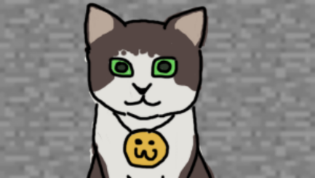

III. An example of fair wins and losses
Risk of Rain 2 is a roguelike fighting game with a unique mechanic: the more time a player spends the stronger the enemies become. To avoid the enemies becoming far stronger than the player, said player must perform a balancing act of collecting and purchasing loot around the stage by killing enemies to gain coins, while also progressing through the game by getting to the next stage to collect and buy more loot.
Taking too long to get more powerful or excessively searching a singular stage for the last chests/items has led to the death of many. However, players can leave any time they want (though they’ll have to defeat a boss to earn their progression). This, alongside the many other measures the game has to help it feel fairer, has made Risk of Rain 2 feel surprisingly fair, especially for a game in the roguelike genre, which is home to a lot of randomization outside the player’s control.
The enemies are also very well designed. They often appear in large crowds, yet somehow you have a good understanding of what’s happening around you when you fight. Information is adequately communicated to players, and that will help make deaths feel fairer and a result of their own incompetence rather than a fault of the game.
That fairness combined with the reward of getting incredibly strong items as a result of your skill and smart decisions, and seeing enemies you once struggled with get defeated easily make Risk of Rain 2 a very enjoyable experience.
Although it’s a game that strays far from Minecraft’s gameplay, the ways it approached its gameplay are exemplary when viewed in its whole.

IV. The cost of competitive multiplayer
Another example is Fortnite. Competitive games with multiplayer can be very fun if done right! The loss feels real and it’s a true test of your skill and decision making that comes with satisfying victories. It may also create interaction with others in the form of rivalries that amplify satisfaction, and also through strong teamwork that strengthens the connection between people.
However, there is a hidden cost inherent to it. In a competitive multiplayer environment, there has to be a loser. In a game of Fortnite, one player has to be 100th place, which feels embarrassing. Half of the players won’t make it to the top 50. Only one player or group can be 1st. Losing sucks! People need to win more than they lose to have fun, but in Fortnite, there will always be a loser. The people behind the game made bots to counteract this, and it came with understandable backlash from the community.[2] Competitive multiplayer is expected to be exactly that: competitive and multiplayer. Adding bots to where players expect real people disrupts the premise and promise of fighting other humans, not a machine.
The playstyle that was advertised and supported in Raid Farms were alliances and rivalries, but that meant the destruction of one group in favor of another. This is yet another issue of Raid Farms and anarchy in general, the core gameplay involves discouraging players from continuing to play. In anarchy Minecraft servers, there is an expectation of hostility among the players in the form of fighting or griefing. However, these activities that come at the cost of another player’s enjoyment. There was an infamous incident of corruption in Raid Farms involving a normal player encountering Pinekitten, a person close to Pinecone, the YouTuber and owner of Raid Farms. The player attempted to kill her, but she was saved by intervention from Pinecone. Afterwards, the player was banned.
This event is clear proof that Pinecone has faced the issue inherent to competitive multiplayer: enjoyment deriving from another person’s loss. He resorted to intervening with cheats to resolve it, which led to the person who attempted to kill Pinekitten, and perhaps even more, to leave.
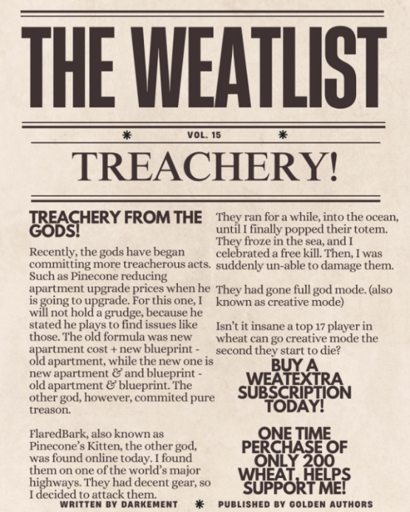[3] 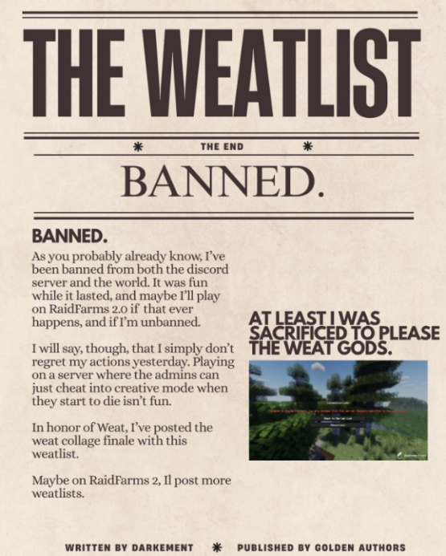[4]
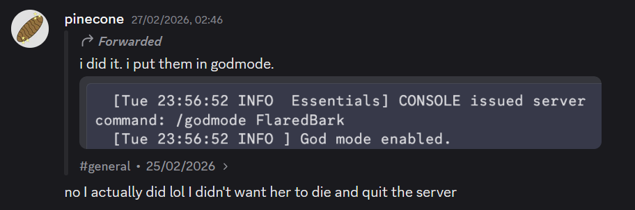[5]
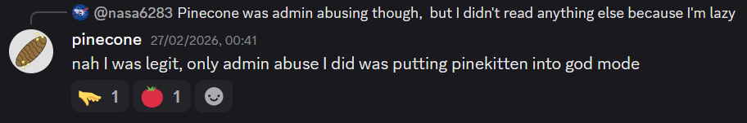[6]
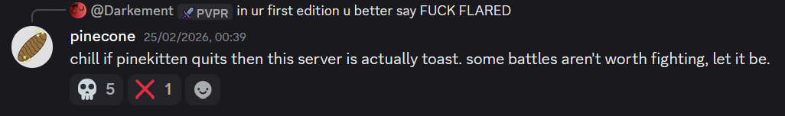[7]
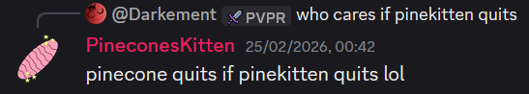[8]

V. Conclusion and closing thoughts
Game design is the core of making games, as it’s the method and adequacy of which a game is made in order to achieve its goals. That is why I believe that more game design discussions are needed in the MSTI, as it’s being disregarded – even though studying it will improve our understanding and ways of addressing issues regarding MST.
Although you may think I’m against competitive multiplayer, I’m not! Competitions can make winning feel more rewarding, like Super Mario Bros, which is a widely successful game, even though it has a strong competitive aspect. Such a game simply has to address the issues that the losers face.

References
[1] Valve, 2023, Half-Life: 25th Anniversary Documentary, https://www.youtube.com/watch?v=TbZ3HzvFEto&t=941s
[2] khaled_o_, 2024, Bots need to be removed they ruin the BR experience…, https://www.reddit.com/r/FortNiteBR/comments/1h94947/bots_need_to_be_removed_they_ruin_the_br/
[3] americanshark, 2026, Raid Farms Discord Server, https://discord.com/channels/1437216473062838334/1440118268642988083/1476023100067025181
[4] americanshark, 2026, Raid Farms Discord Server, https://discord.com/channels/1437216473062838334/1440118268642988083/1476355435392012309
[5] pinecone, 2026, Raid Farms Discord Server, https://discord.com/channels/1437216473062838334/1437216473851629854/1476772481401487544
[6] pinecone, 2026, Raid Farms Discord Server, https://discord.com/channels/1437216473062838334/1437216473851629854/1476741061580816425
[7] pinecone, 2026, Raid Farms Discord Server, https://discord.com/channels/1437216473062838334/1437216473851629854/1476015654657069140

[8] pinekitten, 2026, Raid Farms Discord Server, https://discord.com/channels/1437216473062838334/1437216473851629854/1476016474379386943

Fun in multiplayer environments
IMSC: 1RV1
By: Rev, edited by: MrMillerPink
Introduction
Recently, MrMillerPink published his article “Fun, Wins, and Losses” [1] referring to game design as an optimization tool that should be used in the MSTI. This brief article is, then, my way of following his advice and adding a second block of reflection on this point.
I had thought of conveying this as a comment, but I didn't want it to get lost among the many things that happen in comments; it seemed better, then, to have it published as an article where I could expand a bit more.
Thus, this article aims to point out certain limits that appear when using “game design” in multiplayer spaces, not because they are errors in themselves, but to narrow down the scope of this implication.

I. What is fun?
MrMillerPink cited Gabe Newell, to explain that fun is “The degrees to which the game recognizes and responds to the players choices and actions”. [1]
I find this definition very satisfactory and self-conclusive.
And yet, it seems to me that it appeared in a context that cannot be 100% transferred to server theories. Newell and his team were in the process of designing individual games, where their design encompasses: the environment's reaction, the physical reaction of movement, the reaction to the player's actions, the reactions of the player's enemies... etc.
This problem persists even when MrMillerPink uses the game Fortnite due to a difference I consider key. Minecraft servers, unlike other multiplayer games, do not base their fun and interaction on the design of the game per se, but rather reside in strategic forms of interacting where one cannot have prior information about what other players will do.
In plain English, this means that unlike games like Rainworld (2017), Risk of Rain 2 has a predetermined reaction model: Each entity operates under discrete states (Idle, Chase, Attack). Transitions occur only when specific conditions are met, such as “line of sight” or player proximity. [2]
This does not happen on Minecraft servers. Although this pattern of behaviors can be analyzed in the design of the game itself (as MrMillerPink himself does). The “medium” is different; a Minecraft server involves (or seeks to involve) other players whose reactions cannot be designed a priori as they can in a traditional video game.
This, I believe, means that the “fun” Newell talks about, and by extension what MrMillerPink talks about, is not the only one at play when applied to a strategic multiplayer environment. [1]
On the other hand, this responds to a distinction; a “pre-determined and farmable” recognition reaction is not the same as an interdependent recognition reaction subject to uncertainty.
This means that “Miller's fun” taken to its logical conclusion would lead players, after certain interactions, to learn what is fun in a given game and what is not. This also happens in Minecraft. The phenomenon of farms is basically the logical conclusion of learning the “mechanics” of the loops. Likewise, the automation of interactions with the game occurs because in Minecraft the recognition reaction is pre-determined, farmable, and repeatable under the same conditions.
In contrast, on a server, part of what attracts players and the fun they derive from what I call social fun: the fact of interacting with others. It may be in competitive contexts (winning/losing), but also in broader social contexts where an interaction leads to a reaction, but since both can meet again, that reaction has meaning beyond the initial fun and builds a “profile of meaning.”
Basically, repetition in interactions changes what is fun on a server. After all, you can't farm PvPs, friendships, connections, or economic systems.
Let's think of a player who builds an impressive farm. In Miller's framework, the game recognizes their action (the farm works). But if no one visits it, if no one comments, if no one integrates it into the server's narrative, does it really feel fun? Technical recognition exists, but social recognition does not. And it is the latter that builds community.
With this in mind, I believe this definition must be expanded for a server:
“Fun is the degrees to which the player feels that their actions and choices in the physical game are recognized and valued by the social world in a sustained manner over time.”
This change may seem small, but it is ultimately key. That there exists for the player a “profile of meaning” and that they have one for others as well.
For this, I refer not to my intuition, but to that of MrMillerPink himself in his previous article “A Talk About Anarchy”: [3]
“One of the greatest joys you can experience in life, is to be observed in a positive light by someone interested in you, whether it be family, friend or significant other; Not just in the sense of the core parts of your identity, but also the small things: habits, hobbies, and all the things you care about. It’s a shame that such validation, admiration and respect is sparse throughout society. You haven’t lived till someone likes the way you express yourself”.
This leads me to suggest that the greater the recognition and/or reactions a player's action produces in a social environment, the greater their satisfaction and “fun” within it. No one likes to be ignored.
This is the problem with “Miller's Fun” and my new proposal. And yet, there are still things I would like to cover.

II. The problem of uncertainty
Robert Axelrod in The Evolution of Cooperation (1984) [4] raised the problem of uncertainty, one that caused cooperative environments to fail and led to certain failures in maximizing the interests of those involved, paradoxically due to the belief that their interests were at risk. Paraphrasing Axelrod, the problem is as follows:
“The inability of actors to predict with certainty the intentions, behaviors, and reactions of their counterparts. This informational gap generates a risk of unilateral defection, where the fear of being exploited by the other (behavioral uncertainty) or ignorance about the duration of the relationship (temporal uncertainty) blocks collective action, turning cooperation into a dilemma of failed coordination unless there are signalling or reciprocity mechanisms that stabilize expectations.”
This is useful when talking about servers because the presence of “others” with their own agency and desires that we do not know leads to the uncertainty raised by Axelrod. We fear that others do not share our interests or that they do not want to interact/react to what we do in a “public” space, and as previously stated, it cannot be predicted. Likewise, we cannot take for granted, force, or predict that people will interact with us, or that they will do so positively.
When I apply this to Minecraft environments, I adhere to what MrMillerPink already mentioned. [3]
“My explanation of why the environment of Anarchy servers come about as such is that even if most players in the server don’t desire hostile interactions with one-another, the players who act chaos and destruction create incentives for players to not make efforts to socialize, and instead be suspicious of others whilst also acting viciously to protect themselves. This further alienates players who desire and make efforts towards amity, causing them to leave, making the dominant playerbase to consist of those who contribute to this antisocialness.”
What MrMillerPinker means here is that antisocial behavior is not the majority; instead, in most cases, it is simply the “most rational” action or the one that “makes the most sense” given an environment that favors it. In this sense, Axelrod's problem of uncertainty and the chain of events towards the antisocial that MrMillerPink proposes converge in what Shepsle and Weingast (1987) [5] called “Structure-induced equilibrium.”
That is, “in contexts of high strategic uncertainty, institutions act as incentive structures that alter the utility matrix of agents. The equilibrium is not just the result of individual or group preferences, but a product of the social environment which, by imposing restrictions and sanctions, reduces the possibilities of others' behavior, making them predictable and allowing actors to coordinate their actions under a cost-benefit structure stabilized by the norm itself.” [5]
If this is true (and MrMillerPink seems to recognize that it is), then both the uncertainty and the decision chain of other actors constitute the “Environment” or “structure” that provides incentives or sanctions for players' actions. In an environment where one does not know what reaction actions cause, nor which players are “good or bad,” the individual player or group tend to move away as it is the action that best protects their own interests in the face of high uncertainty.
This is why, for example, players on servers tend to move away from each other even when resources for survival are present in abundance.
This phenomenon occurs even more on servers of an anarchic nature, as we would expect if what MrMillerPink proposes is true. [3]

III. Minecraft and Fortnite
This problem in general also serves to differentiate interaction and fun in Minecraft and Fortnite. In the latter, players literally fall from the sky on a bus with their expectations clear; there are 100 players and only one can be alive. There is no uncertainty about what others want to do, there are no “other things” to do in the meantime; the storm closes the available space, incentivizing movement towards the center. The structure induces an equilibrium where the dominant action is to kill each other.
There may be small variations: if there is a very good player, some might target them in a temporary alliance. But as MrMillerPink [1] said in his latest article, people like to win, they like (even more) the reward for winning. Fortnite's structure therefore demands that any alliance be unstable, short, conditional, and purely utilitarian. Moreover, it is most likely that 99.9% of Fortnite players will never meet or never meet in a truly meaningful way, which makes it easier to betray, lie, deceive, flee, or target. If it were different and players had to play together again for a few matches, for example, then we would expect to see fewer of these individualistic behaviors because acting that way would be frowned upon and could even lead to being targeted, which would take away the fun.
In contrast, a Minecraft server is already in a different structural state; fun does not derive from purely individual achievements (surviving, doing things to progress, etc.). It is also founded on good coexistence, on fun, meaningful interactions/reactions (as we saw in the previous chapter). Likewise, Minecraft's design allows, beyond physical limitations, freedom to shape the opportunity structure on a server. Minecraft does not have “one objective”; there are perhaps incentives to beat the game and progress materially, but beyond that, it does not have Fortnite's structure of “you kill or you lose.” This allows for the existence of anarchic servers, where the structure leads to antisocial behaviors [3], but also a great variety of servers that can propose an explicit objective like Fortnite, or that can set rules to avoid outcomes they don't like.
This leads me to one of the solutions (or rather considerations) from Shepsle and Weingast's (1987) [5] theory, who considered that in their model, institutions not only limit available options but also act as mechanisms for reducing strategic uncertainty by stabilizing expectations and shaping the cost-benefit structure for rational actors. For our purpose: Institutions are Rules, customs, and social norms.
These considerations lead me to think that what MrMillerPink called “game design” could be adapted to a Minecraft server as “institutional design” because it is the rules that shape what players do or do not do, and allow for the “design” of reactions and recognition that respond to the player's decisions and actions.

Conclusion
In the end, all of this points to a discomfort worth holding onto. Game design gives us powerful tools, but when we transfer them to multiplayer servers, something resists. We cannot program one player's reaction to another, neither farm friendships nor automate respect.
And yet, what we cannot program is precisely what matters most.
Fun on a server is not just that the game responds to our actions. It's that someone else sees them, remembers them, values them. It's that awkward and wonderful moment when a stranger comments on your build, or when your name appears in a conversation you weren't expecting. It is, as Miller himself said before, being observed by someone who cares about how you express yourself.
The problem is that this kind of recognition cannot be directly designed. You can only design the conditions for it to occur. This is, rules that make others' behavior predictable, spaces that invite interaction, institutions that punish betrayal and reward trust. Institutional design prepares the soil for community to decide to grow.
And yet, uncertainty will always remain; The uncertainty about whether the other will cooperate or betray. The uncertainty about whether our actions will be recognized or ignored. This uncertainty is what I consider a condition of possibility. Because if we could predict everything, if every interaction were guaranteed, then recognition would lose its value. It would be like just another farm: efficient, predictable, and empty.
Perhaps that's why the servers that last are not always the most “Game immersed” or even the best to play on. The servers that last the most are those where, despite the uncertainty, people keep choosing to form a connection.

References
[1] MrMillerPink, 2026, FUN, WINS, AND LOSSES, Institute of Minecraft Studies
[2] Hopoo Games, 2019, How moving from 2D to 3D shaped the design of Risk of Rain 2, https://www.gamedeveloper.com/design/how-moving-from-2d-to-3d-shaped-the-design-of-i-risk-of-rain-2-i-
[3] MrMillerPink, 2026, A Talk About Anarchy, Institute of Minecraft Studies
[4] Axelrod, R., 1984, The Evolution of Cooperation
[5] Shepsle, K. A., & Weingast, B. R., 1987, The Institutional Foundations of Committee Power, The American Political Science Journal

Raid Farms: A symbol of resistance
IMSC: 1MA1
By: matcha_tea, edited by: ghastlygrenadine
Background
Raid Farms was a server experiment started by YouTuber PineconeLP that described itself as a “semi-anarchyish[sic] Minecraft server with a unique blend of features,” intending to “…make Minecraft servers fun again”. The server’s establishment followed a video made by PineconeLP titled “Why Most Minecraft Servers Are Boring,” which described the need for anarchy and pvp in order to achieve fun in a server.
However, since its launch on the 16th of November 2025, players have gradually lost interest and became bored of the server. On the 1st of March 2026, Raid Farms officially shut down. [3][5][6]
Despite its downfall, Raid Farms was a unique and interesting experiment. Through its ups and downs, its playerbase largely stayed put and anticipated for the next big change.
This article will focus on how these players bonded, established communities, and seemingly played against the server’s established intentions.

I. The spawn square
Most new players’ experience of Raid Farms would be its spawn area – the 100 by 100 metre square that serves as the centre of the server, houses shop and studio apartment plots, and has a quaint lake where players can fish. The square also has PvP protection and is the only area in the entire world where griefing is banned, which explains why immediately outside the square massive, towering cobblestone structures loom over you.
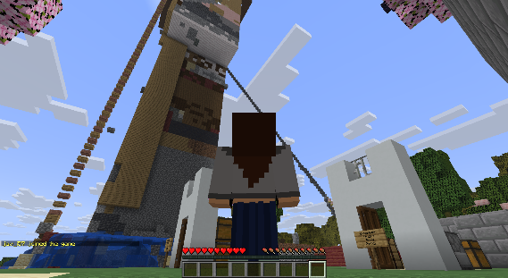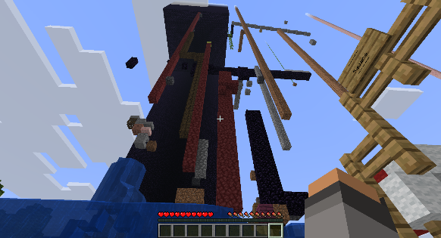
Although, despite the initial unsettling feeling that the griefing brings, these structures actually provide valuable nostalgia and realism to the server, reinforcing the sense of community early on in a new player’s experience. Each skyscraper tells a story of history, previous player interactions, and a once lively community that made a boring wilderness have a sense of character, even if it is unsightly.
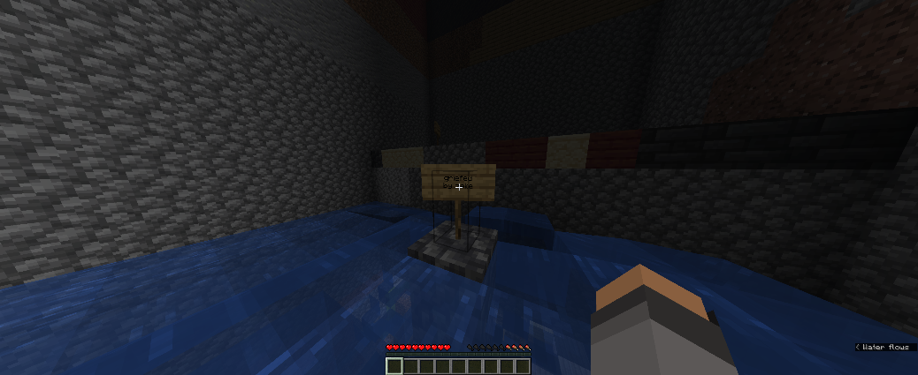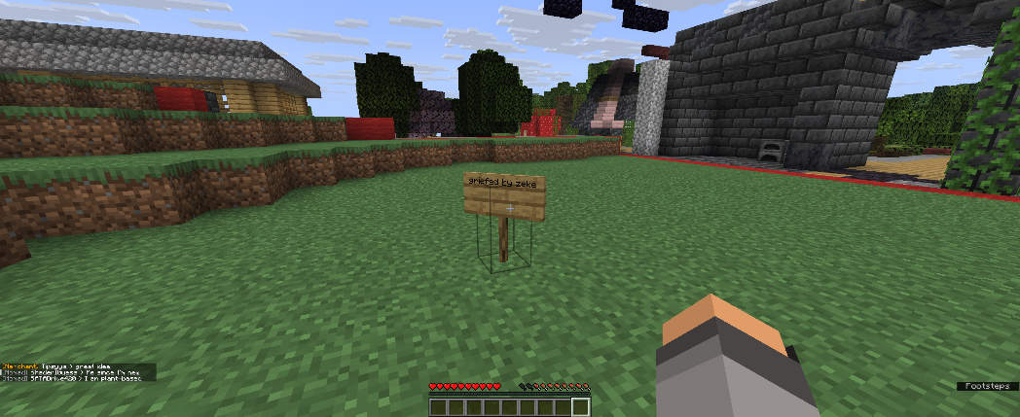
An infamous griefer was Zeke, who has a celebrity-like status within the server. He has a presence in the form of signs around the whole world, signed with “griefed by zeke”. Zekethegameboy. [8]

II. The tunnel
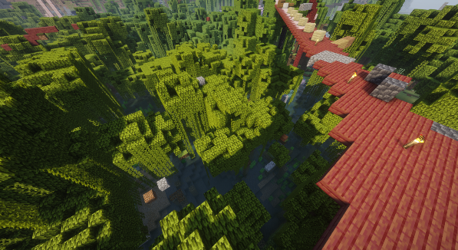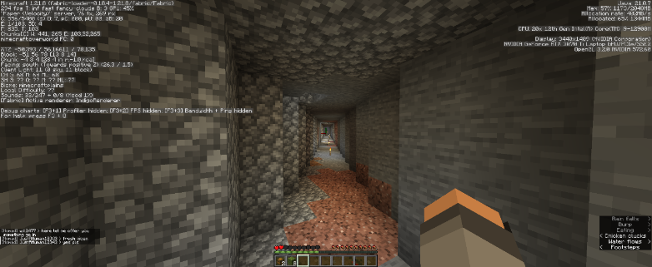
Notice the cobblestone, dirt, and other planks dotted around on the seafloor. Players try to adapt to traverse the tricky terrain, but the many breaks in between show they usually resort to other ways of travel (e.g. on top of the mangrove trees).
I came across a tunnel running outside the Raid Farm’s spawn square that ran under a waterlogged swamp, eventually emerging into the outskirts of a savannah.
The diagonal passageway reminded me of foot tunnels under rumbly tube tracks in London, loosely put together, filthy everywhere, and littered with masses of cigarette butts and random splashes of paint. The imperfectness of this tunnel describes Raid Farms as a server very well. It embodies the spirit of anarchy in all its forms – carelessness, disorder, and chaos.
In servers where griefing is permitted and has no restrictions, the time and effort required to build a building will always be greater than the effort required to destroy it with TNT. The ragtag-like presentation and composition of the tunnel is a result of players understanding this fact. The result is a randomly, carelessly repaired, unmanaged tunnel. I will refer to this phenomenon as the Griefing Imbalance.
In a server where griefing is banned, plots are enabled, and almost all players do not want to grief, a nicer looking tunnel made of planks, logs, and lit with lanterns may have been built. Helpful signs along the way would guide players to their destinations.
However, in Raid Farms, such a construction would be an extremely large risk. A griefer could easily destroy the tunnel that took hours, even days to build, in seconds. The large structures around spawn also amplify to naive new players that such efforts are welcomed, but also warns that it is likely to be short-lived.
You may conclude because of this that Raid Farms is a disconnected, unfriendly community due to its hostile architecture. Nevertheless, like Cialazar, a town I will talk about in the next section, the message that is associated with the unpolished tunnel is what makes the server have an unseen community. It communicates the resistance and resilience of players in the server despite its circumstances. So, in fact, the Raid Farms community is stronger than any other.

III. Cialazar
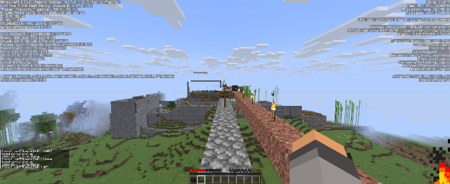
To the four cardinal directions around the square, there are many bridges made from cheap, easy-to-find materials running in parallel with each other, seemingly leading nowhere. This is the first of many examples in Raid Farms where the consequences of its anarchic nature are displayed through the structure’s composition.
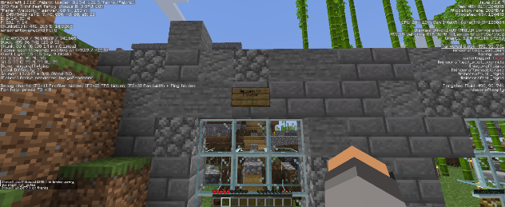
At the end of one of these bridges, you are greeted with a sign showing the city’s name – Cialazar – apparently named after its founder, Ciala, according to Ob1cloney1234. [2]
Looking in the Discord server again, the first mention of it seems to be by someone named Pudd in the #general chat. Similarly, the same player with the tag PuddPuddofMaja was also the first to say the city’s name in the Minecraft chat, pointing another player to its very own Discord server, on the 18th of November 2025. [7]
This is just one small part of the very fascinating lore and story of this specific town, and of course there are numerous more dotted around the world. The abandoned ghost city is also referred to as Ctown, which is most likely a portmanteau of Cialazar and town.
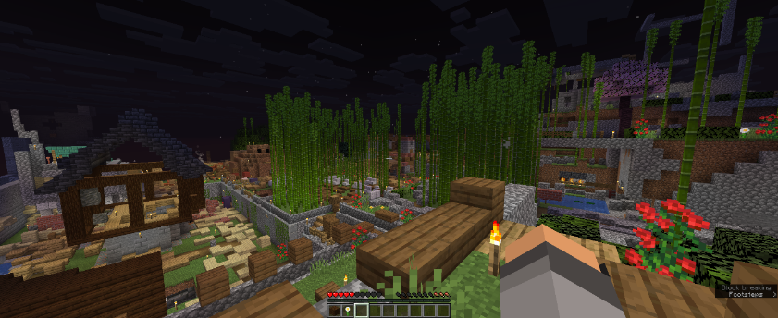
Inside the city’s walls, there were unmanaged stalks of bamboo reaching up to twenty or thirty blocks tall, evident of the city’s age and its history. The unmanaged, wild, overgrown bamboo made me feel like I was wading through unmanaged fields in the English countryside, with bees, mosquitoes, and flies all swarming around me as I explored around. The mildly griefed ground also mimicked that unmanaged countryside look; the imperfection and ruggedness gave the city character and tells its once vibrant story.
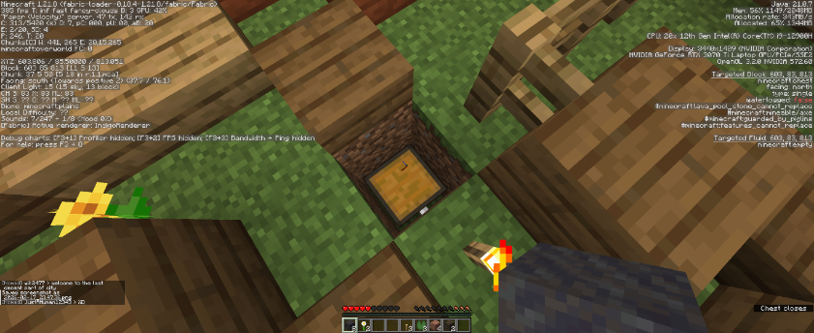
Another observation I made was the buried chests around the city – a cheap and efficient way that players used to protect their items from raiders and griefers.
These kinds of chests are a direct result of anarchic server design with unrestricted griefing and PvP, forcing less equipped players to have to hide from other players to survive. This is in direct contrast to one of Raid Farm’s main goals – to foster communities and player interaction. [3]
Furthermore, this is also another example of the Griefing Imbalance, where the effort put into mining, farming, and collecting resources must be hidden away to prevent hostile actors destroying that progress. Players, who ultimately act as people, need a common space, physical or otherwise, to bond and form relationships. However, Raid Farms punished establishments and institutions that represented communities, people, and societies through the imbalance, which furthered the distance between players.
Although, Ctown is the perfect microcosm for Raid Farms, where community exists at the same time as seclusion and scepticism. The server was systematically structured to be an anarchy server, but the players inhabit it as if it was an SMP server. The balance in between is the amalgamation that produces this small settlement. Although this article does not intend to discuss why the server failed, I believe that even though Raid Farm’s intentions as a server mixing the best of both worlds was successful, neither world’s players enjoyed the final product.

IV. The Diner
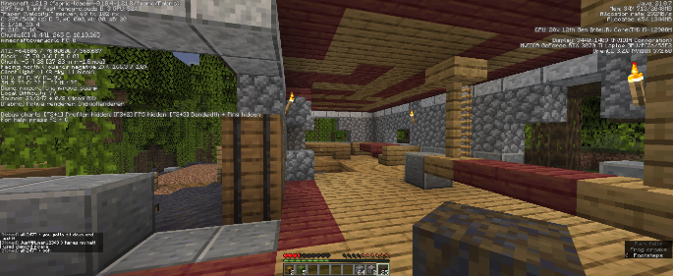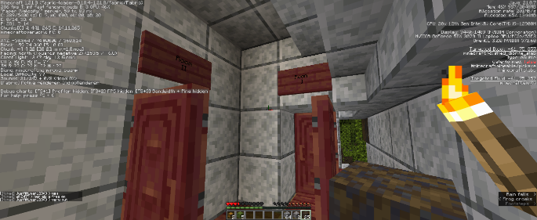
This building had a restaurant/diner on the bottom, with hotel rooms or some kind of flats above.
In a spread out, disconnected server, the more signs a place has, the more people visited it, and found a sense of comfort and belonging, leading them to place a sign to mark their presence in the very rare communal spaces around the map. The “X was here” signs allow players to not just be a random person, a meaningless entity in the server, but is the only way (in Raid Farm’s anarchic server) for its members to share a moment – and most importantly, a space.
I talked about this in my recent video [1] where I explain the effects and mechanisms of healthy and harmful interactions, however it is also worth pointing out the indirect interactions a server’s environment can provide and act upon a player.
Servers have a direct, symbiotic relationship with players, where players influence the environment, and the environment influences the players’ decisions; this means that anything placed in the environment is directly interpreted by bystanders as influential to them, especially so if the structure was made by a player – in Raid Farms, these influential structures are signs.

V. The Compound
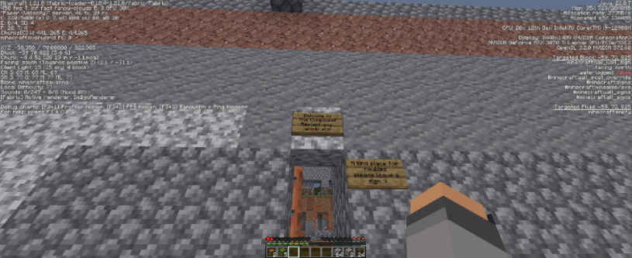
The last structure I went to was called The Compound – a small, rectangular, cobblestone structure, with a wheat farm in the middle. There are some chests and barrels dotted around the farm too for storing wheat seeds, but they are all scavenged empty.
The wheat farm being at The Compound’s very centre shows how a server’s mechanisms influences player behaviour greatly. If it was not for wheat’s “value” as a currency (even though it failed, and players did not like it), the people who built this rudimentary building introducing new players would not have a wheat farm as its welcome. This speaks to the actual consequence and effect of the wheat currency, which is as a social glue. In a server that has no real, effective mechanism to draw players into a central, communal area, something else must shape their identity.
You might even be able to draw comparisons between minority diaspora communities with Raid Farms players – groups of people who cannot interact or share experiences together due to some kind of systemic oppression or force, and must use discrete, shared, community spaces where they can interact without outside intervention attempting to pull them apart. Truthfully, the cohesion that Raid Farms players have and showed when Pinecone announced the server’s closure was evident – they were never enemies or hostile to each other, but the system in which they live in created the environment where they are not able to interact freely with each other, and even if they were, it was not something that Raid Farms actively encouraged.

Conclusion
De jure anarchy servers with a de facto SMP playerbase (survival Minecraft players who want to interact with other players and share builds) will always create a stark divide between the system’s expected outcome and the players’ inherent assumed outcomes on that server. Raid Farms’ mechanisms allowed its landscape to be griefed, which caused players to spread out because of that fact. However, players have always secretly been yearning for interactions, for community, for someone to play with, and this was evident by the masses of screenshots people shared on Raid Farms’ Discord server for everyone to reminisce on the systemic oppression of the people’s will for community.

References
[1] matcha_tea, 2026, Why Does Conflict Not Make Servers Fun?, https://www.youtube.com/watch?v=EcQBZEwf5zI
[2] Ob1cloney1234, 2025, Raid Farms Discord server, https://discord.com/channels/1437216473062838334/1440351193393004584/1441036156245639310
[3] PineconeLP, 2025, Why Most Minecraft Servers Are Boring, https://www.youtube.com/watch?v=OcLS17u62a4
[4] PineconeLP, 2025, Raid Farms Discord server, https://discord.com/channels/1437216473062838334/1437831180375425197/1439742568102367353
[5] PineconeLP, 2025, raidfarms.com, https://web.archive.org/web/20260122163834/https://www.raidfarms.com/
[6] PineconeLP, 2026, Raid Farms Discord server, https://discord.com/channels/1437216473062838334/1437831180375425197/1476262168562372689
[7] PuddPuddofMaja, 2025, Raid Farms Discord server, https://discord.com/channels/1437216473062838334/1440351193393004584/1440388166354862231
[8] Zekethegameboy, 2026, Raid Farms Discord server, https://discord.com/channels/1437216473062838334/1437216473851629854/1479612667004977356

The Five Motivations
IMSC: 1SA1
By: Snorka, edited by: matcha_tea
Introduction
As server owners and server theorists, our goal is to maximize fun, but that is a nebulous goal with many disparate ways to accomplish it. This article’s aim is to classify the different reasons people have fun on Minecraft servers so future theories can focus on maximizing certain motivations rather than just aiming for the subjective target of “fun.”
There are the five motivations: accomplishment, creativity, discovery, connection, and domination. Each of them is present in everyone, just to different degrees. Of course, players also have their own preferences within these categories and separate from them (e.g. someone might prefer building in a modern style or a fantasy one, but both fit within the creativity motivation), but any time you are having fun on a server, it does fit into one or more of the motivations.

I. Accomplishment
This is perhaps the broadest category. Players may feel accomplishment after completing something difficult – the main challenge with adding accomplishment to a server is weighing difficulty so you add accomplishment without making the game frustrating. The kind of challenge players must overcome can come in many forms: combat challenges obviously come to mind, but building farms and other redstone machines is another common thing players do to feel accomplished. The first three motivations can all be achieved in singleplayer, but accomplishment is often even better when you can show off what you have done to your servermates. When optimizing for accomplishment, make sure that players’ accomplishments can benefit others!

II. Creativity
A big chunk of Minecraft players are builders first and foremost. Creativity is the motivation that explains that. Again, the main reason to build on a server instead of a solo world is so other people can see what you built, so make sure that is possible. When optimizing for creativity, you want to make most desirable building materials easy to obtain. Although you can get accomplishment from building with netherite or beacons, that is no more creatively stimulating than building with cheaper stuff. Another way that accomplishment can look like creativity is when building is mechanically useful. Making effective fortifications or prisons is an accomplishment, decorating them is creativity. Keep that in mind!

III. Discovery
People like seeing new things. All the structures and biomes to explore in vanilla contribute to the experience of someone who cares a lot about discovery, but there is only so much to see there. On a server, ignoring any mods that add more things to see, players can experience discovery by traveling and coming across what other players have built. To optimize for discovery, make sure that is possible! If griefing is allowed, builders need to hide their builds, which harms the discovery experience. Also, concentrating builds in certain areas can make them easier to find. There’s also a less obvious element of discovering game mechanics (again, this is largely through mods for regular server players) and social dynamics. You can absolutely get a sense of discovery through observing a server’s economy, politics, and wars.

IV. Connection
This is the first of the server-exclusive motivations. People like spending time with their friends! When optimizing for connection, make sure it is easy to meet up with friends (such as with tp commands) and to make new ones (this could be a whole theory in itself). Another aspect of connection is that people like working together with a group, even if the group are not all close friends. Pre-established or naturally arising factions are great for this, as well as any content that is only possible (or much easier) by doing in a group. Domination: This motivation is all about feeling superior to other people. This can come from winning in competitions, like PvP or minigames, and it can also come from being in charge of a group or faction. Including ranks is great for domination-motivated players. This is absolutely one of the more dangerous motivations to optimize for, though. For one person to win, other people have to lose, and many discouraging moments when you get killed or griefed come from other players chasing domination. But it is still a major way people have fun, especially in online games.

Social Priming and Server Well-Being
IMSC: 1ML1
By: Moldypizzar0ll, edited by: Rev and retrooper
I. Introduction.
There is a strong intuition, if not strong empirical evidence, that preexisting concepts, relationships, and moral obligations play a substantive role in governing the interactions of players in virtual worlds. I will argue that, at least in the case of Minecraft servers specifically, conceptual and social cohesion in the real world prior to its instantiation in Minecraft is, on the whole, detrimental to the life of a server. This is likely due to the fact that such a cohesion presupposes shared utility functions among the constitutive members of a cohesive group, which, when augmented by the fact that Minecraft’s gameplay loops allow the player to obtain an extreme abundance of resources beyond an initial curve, leads to the prioritization of the individual cohesive unit rather than the server as a whole.

II. Terminological Clarifications.
A. Priming
A primed player is a player with preexisting concepts, moral obligations, and rational norms that bear relevantly on their behavior in-game. To some extent, all players are primed, although some may be more relevantly primed than others. For example, X may be said to have, pro tanto, a greater degree of priming than Y given that X has had experience playing sandbox-type games before, while Y has had no such experience.
B. Social Priming
A socially primed player is a primed player whose set of conceptual elements includes preexisting real-world social relationships. However, these relations must have certain necessary and sufficient conditions; for it is not sufficient to stipulate that any preexisting social relationship is a sufficient condition for social priming. Let S be a set of players X, Y, and Z. Insofar as all players in the set are necessarily:
i) Acquainted with each other and/or share a certain degree of friendship (in
the ordinary sense of the term),
ii) Cooperate with each other more often than not, ceteris paribus, and
iii) Share similar goals, aims, and moral values more often than not, ceteris
paribus,
then X, Y, and Z can be said to be socially primed with respect to S. From hereon I will assume that any given socially primed player meets conditions (i)-(iii) and is primed with respect to a set of players.

C. Utility Functions
A utility function is a function that takes states of affairs of the world as inputs and utility as its output. Utility is often conceived of in terms of utils. A util is an arbitrary unit used to posit the utility of a state of affairs or action. Consider two possible actions, A₁ and A₂, such that A₁ produces five utils and A₂ produces two utils. On standard utilitarian views, A₁ is the morally obligatory action to take, for it results in a greater amount of utility than A₂. Hence, the utility function of an agent, or in our case, a player, measures the utility generated by certain states of affairs relative to an individual. Therefore, it is possible for individual utility functions to differ across agents/players. Consider two agents, P and Q, with utility functions u(P) and u(Q), where u(x) can be said to be the general form of a utility function. Under u(P), the number of utils gained by eating ice cream may amount to ten; under u(Q), the number of utils gained by doing the same thing may only amount to one. Moreover, certain states of affairs or actions may not even figure into agents’ utility functions at all. This will come into play later.

III. Server Goals and Player Properties
A. The Purpose of a Server
It is generally assumed, if not a widely held intuition, that the purpose of a server is to maximize the amount of enjoyment for the greatest number of players. Though this broadly utilitarian characterization is by no means the only sort of characterization that could be made here, it will prove useful in setting a fixed point around which the parts of the server may revolve (players, moderation, gameplay, etc.). The gameplay loops of Minecraft, within the context of a server, are often used to coordinate the behavioral patterns of players around certain determinate goals or ends. These goals or ends, by extension, generally serve to increase the extent to which players may enjoy themselves on the server. Because these ends are only valuable insofar as players cooperate with others in order to satisfy those ends, we may be in a position to claim that players include interactions with other players squarely within the domain of their utility functions. Furthermore, those players would assign positive values to the relevant outputs of those functions. Let the cumulative utility of all shared events that involve player-to-player interaction be the Server Utility (SU).
The central claim here (C) is that:
(C) All things being equal, i.e., under ideal conditions, servers with players who are socially primed, viz., with preexisting social, conceptual, and moral relationships with others in the relevant ways, will always have a lower SU than servers with players who are not socially primed.
If this claim is true, social priming is, on the whole, undesirable for a server. If this claim is to be proven, we must explore the utility functions of socially primed players.
B. Priority
Recall the set S of players X, Y, and Z, where each player is socially primed with respect to S. Assume additionally that each player in the set has a utility function. Because of conditions (i)-(iii) for social priming, it would be quite difficult to argue that X, Y, and Z do not consider their fellow players within their utility functions; for if it were to be the case that X could either help Y or another random player, say A, X will in the majority of cases gain more utility by helping Y rather than A; furthermore, Y benefits from having X help them when needed. The dependence relation is thus symmetrical. Let us formulate the first derived claim (D₁), or the PRIORITY premise thus:
(D₁) For any group of players socially primed with respect to a set, the utility functions of each of the players within the set take priority over the utility functions of any other player, barring exceptional circumstances (e.g. when there are only strangers present on the server for a given time).
The crucial thing to note here is that priming entails PRIORITY; as a player, it is in my best interests to prioritize my preexisting friends and social relationships over those that I hardly have any acquaintance with. Hence, I will prioritize the well-being of my friends over the well-being of the rest of the server.
This, however, is not enough to prove (C) on its own. It is a trivial observation that I tend to prioritize people I already know over people that I do not know (yet); but this does not entail, logically nor probabilistically, that this is harmful to the server overall. I can include both the general well-being of the server and the well-being of my compatriots within my utility function. This, however, need not always be the case in situations where social priming is involved.
C. First Steps to Exclusion
Though priority is one way in which a utility function can bear a relation to other utility functions, in that I prioritize certain agents’ functions over others, there is a second way in which a utility function can have a relation (or lack thereof) to other functions, that being exclusion. Let us state the first exclusion premise (E) thus:
(E) X excludes a utility function u(x) from their own, u(X), when none of the outputs of u(x) figure into the inputs of u(X).
However, as of yet, we do not have a reason to think that socially primed players exclude the utility functions of other server members in any substantive way. At this point, though, we may offer a probabilistic argument for why priority leads to exclusion. This argument is predicated on the properties of the feedback loops in Minecraft itself.
D. Scarcity and Exclusion
In the real world, resources are scarce; economic theory attempts to cope with this fact by determining the optimal course of action given the constraints on what we can choose. Minecraft, however, is devoid of scarcity altogether. The game has a theoretically infinite number of resources (if not a functionally unlimited amount); the only barrier is technological, or skill based. You cannot access certain resources given that you do not have the means to acquire them, such as farms, equipment, enchantments, etc.; but given that you do have those means, the number of resources available for you to collect is functionally indefinite.
This means that any given player is entirely self-sufficient; if they so wish, they need not depend on other players in any capacity, for they are not bound by scarcity in the same way real-world agents are so bound. The crucial move here is to observe that this feature applies equally well to groups of players. If a group of players decides to become self-sufficient, as they cannot be said to be hampered by any sort of real scarcity, they certainly can do so with no effect on other players in the server in question. Hence, any calculations or rational assumptions regarding the management of resources, the well-being of the players within the group, or the overall experience of the group on the server need not factor in, to any extent, the utility functions of other players or groups of players. In this case, first exclusion (E) obtains. A subsidiary move here we must make is that a set of socially primed players with prior utility functions is the most apt kind of group to exhibit first exclusion; for, being primed already with preexisting utility functions, the probability of their becoming self-sufficient without any dependency whatsoever on other players is quite high. Therefore, let us consolidate these claims into our second derived claim (D₂), or the exclusion premise:
(D2) i) X excludes a utility function u(x) from their own, u(X), when none of the outputs of u(x) figure into the inputs of u(X). ii) A set of socially primed players with prior utility functions is the most apt kind of group to exhibit (i) pertaining to the rest of the server.

IV. The Full Argument.
It is evident that if (D₂) obtains, then a server with socially primed players will usually always have a lower SU than servers without socially primed players. For if (D₂) in fact obtains, the set of socially primed players with respect to that set excludes others’ utility functions from their own evaluations, and hence server-wide events or other server-wide utility-maximizing forces are excluded from the evaluative purview of the socially primed set. Let us put together the overarching argument as follows, assuming ideal conditions, e.g. that there are other players, that these players are not socially primed, that all the utility functions work regularly, etc.:
Premise 1. There is a set of players S such that the players are socially primed with respect to S.
Premise 2. (PRIORITY) If there is a group of players socially primed with respect to a set, then the utility functions of each of the players within the set take priority over the utility functions of any other player, barring exceptional circumstances.
Intermediate Conclusion 1. Each of the utility functions of the players in S take priority.
Premise 3. (exclusion) i) X excludes a utility function u(x) from their own, u(X), when none of the outputs of u(x) figure into the inputs of u(X).
ii) A set of socially primed players with prior utility functions is the most apt kind of group to exhibit (i) pertaining to the rest of the server.
Intermediate Conclusion 2. S is of the sort that is most likely to exhibit exclusion.
Intermediate Conclusion 3. So, S exhibits exclusion by probability.
Premise 4. If a server has a set of players that exhibits exclusion, the SU of that server will on the whole be lower than a server without such a set.
Conclusion. (C) All things being equal, i.e., under ideal conditions, servers with players who are socially primed, viz., with preexisting social, conceptual, and moral relationships with others in the relevant ways, will always have a lower SU than servers with players who are not socially primed.

V. Potential Solutions and Conclusion.
This conclusion accords well with observation; often, preexisting cliques and groups are scarcely willing to participate in the activities of a server as a whole and prefer to keep to themselves and their own sphere of action. This is often to the detriment of the server, as such behavior limits player-to-player interaction, dulls the social life of the server, and renders the server down to a platform on which individual groups can play on a server without fear of having to interact with anyone else.
All the while, this sort of behavior occurs under perfectly rational (in a sense) conditions; it is through no fault of the socially primed player’s own that they prefer to help or cooperate with those whom they trust rather than random people on the server. This is simply how we value others’ actions relative to those we interact with more often. This does not touch, however, on the moral obligations people have towards others on a server, which may well entail that they interact with strangers for the sake of the well-being of all and the server at large, a position that I myself find quite plausible. There is also the problem of intra-server cohesion, which makes manifest the possibility that priority and exclusion obtain even in groups formed within the server rather than socially-primed players. If this so happens to be the case, which it certainly is given that people often form friendships and social groups on the server itself, what is their ontological and ethical status? Should the server administration curtail their formation, or deal with their consequences as they go along? What to do about this phenomenon, though, is not within the scope of this article.
The most obvious solution, assuming that socially primed players will always be present to some extent, is to integrate more elegantly the incentives of the server with the incentives that the socially primed player feels compelled to act on with respect to the set in which they are primed. A server may restrict resources and create a sense of scarcity in order that groups are forced to cooperate and interact. A server may also enforce proximity requirements, requiring all players to stay within a certain area so as to promote cooperation and shared ends. Another potential route is the elimination of socially primed players altogether; if everyone were to lack social priming, there may be more of an incentive on the part of each individual player to foment social interactions for their continued enjoyment. I, personally, have no opinions on the matter, apart from generally accepting the conclusion that unregulated social priming is, overall, detrimental; I leave it up as an exercise to the reader to determine what sort of solution in this situation, given the foregoing assumptions, maximizes the well-being of a server.

References
[1] Rawls, J. (1999). A Theory of Justice: Revised Edition. Harvard University Press.
[2] Steele, Katie, and H. Orri Stefánsson, Decision Theory, The Stanford Encyclopedia of Philosophy (Fall 2025 Edition), Edward N. Zalta & Uri Nodelman (eds.)

Afterword
By: matcha_tea (Editor-in-chief)
Dear reader, thank you for reading! I had the absolute pleasure of chairing, leading, and establishing the first ever edition of the IMS journal. I truly had a great time, despite the amount of unexpected organising there was involved in curating this journal. I do hope it has given the reader a fabulous introduction to the type of work we do at the IMS, and maybe this has inspired you to write a theory or article yourself too!
I would like to thank retrooper for first proposing the idea of having a journal, then a former member, hiim, for bringing this up and firing up my curiosity.
I also want to thank KingGame and Moldypizzar0ll for helping to push me over the edge in finally starting the journal – I really would’ve sat on it for way too long if not for these two people.
Thanks also goes to Rev for his tens of thousands of words and hours upon hours spent writing his theories and essays, so that we saw the viability and popularity of a potential IMS journal.
Turtle also contributed greatly to running the main IMS Discord server, keeping it active, and being an absolute star in organising everything from votes to the upcoming event in the Summer – for that I’m massively appreciative. Without his work, the server would not receive the attention it so desperately needs.
I thank retrooper again for giving me motivation as I was procrastinating when he showed me someone’s DM to him on Discord, asking about the journal. The excitement I seemingly buried sprung back to life, and we delivered this masterpiece.
Finally, all the editors: ghastlygrenadine; koviubi; MrMillerPink; retrooper, and Rev, who contributed to editing, reviewing, and providing feedback on all the articles above. They applied to be an editor in early March, not knowing how disorganised everything was, and yet stayed put and worked as hard as they could.
I have learned a lot from this journal both personally and in how a second edition could operate. More planning will be done this time, and I anticipate applications for a new position – reviewer – will be out this June. Hopefully, the second edition of the IMS Journal will be released in early July, just in time for the summer holidays.

Again, thank you very much for reading. I hope this has inspired you or helped you learn more about the IMS and MST!

I will assume for simplicity’s sake that a relevant set for us contains three or more players.
By “ordinary” I simply mean the common-sense, non-technical sense of the word.
See [2]
Note that this does not necessarily include moderators/staff, or administrators. On this view, if they benefit in any capacity, they only do so contingently (I doubt, from my experience, that they enjoy any part of it). This may obviously be argued against, but for our purposes here I will take the well-being of the players specifically as the primary object of study.
This notion of priority is an heir of Rawls’s notion of lexical priority, used primarily in ethics and political philosophy. See [1]
I use priority in lowercase to indicate the concept, while I use PRIORITY in capital letters to indicate the claim itself. This also goes with further concepts and premises found later.
This, of course, excludes edge cases in which there are indeed scarce resources, e.g. dragon eggs; but the point here is that most resources in the game that matter are functionally infinite, and available to anyone with the requisite means and determination.

